**SYSTEM TESTING**

**Testing Type**

**Selenium**

**6.1 SELEMIUM TESTING**

**Online.java**

**package** selenium1p;

**import** org.openqa.selenium.By;

**import** org.openqa.selenium.WebDriver;

**import** org.openqa.selenium.WebElement;

**import** org.openqa.selenium.chrome.ChromeDriver;

**public** **class** online{

**public** **static** **void** main(String[] args) {

System.*setProperty*("webdriver.gecko.driver",

"C:\\Users\\chait\\Downloads\\chromedriver_win32\\chromedriver.exe");

WebDriver driver = **new** ChromeDriver();

//URL launch

driver.get("https://www.dominos.co.in/");

//identify username

WebElement l = driver.findElement(By.*name*("username"));

l.sendKeys("Pass@gmail.com");

//identify password

WebElement p = driver.findElement(By.*name*("password"));

p.sendKeys("Pass@123");

WebElement b = driver.findElement(By.*className*("Igw0E"));

b.click();

//obtain value entered for username

String s = l.getAttribute("value");

System.***out***.println("Value entered for username: " + s);

//quit browser

driver.quit();

}

}

**6.2 Screen Designing**

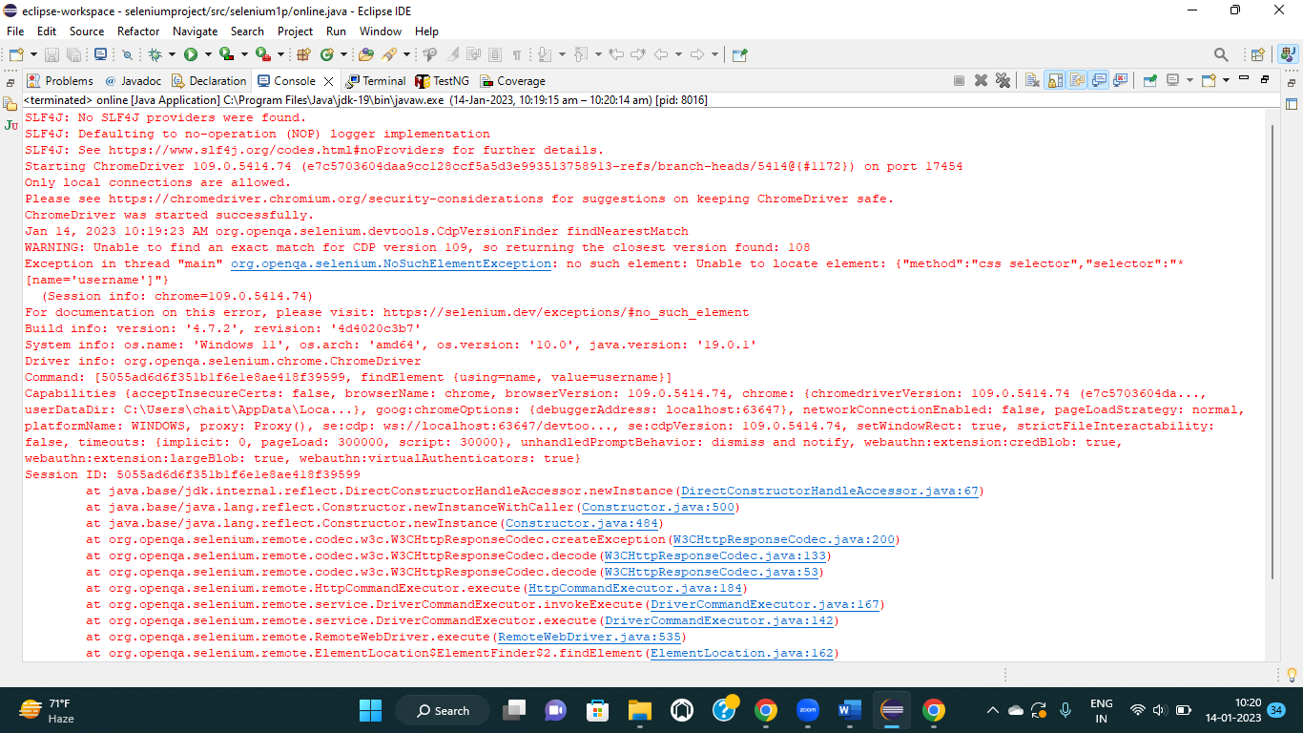

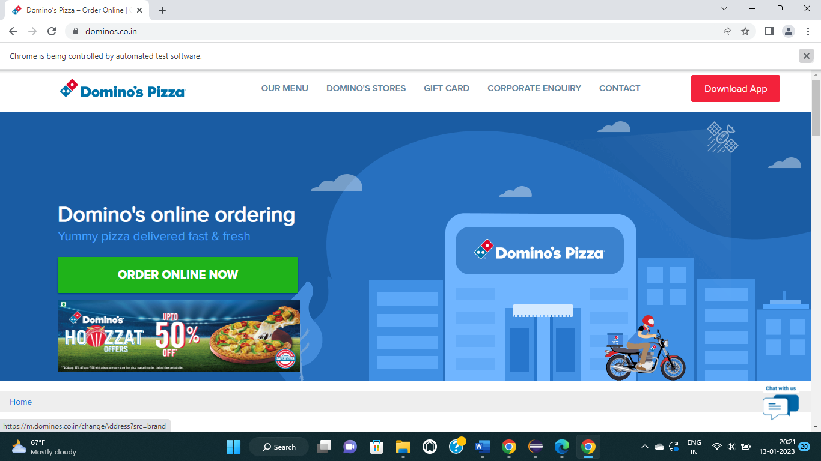

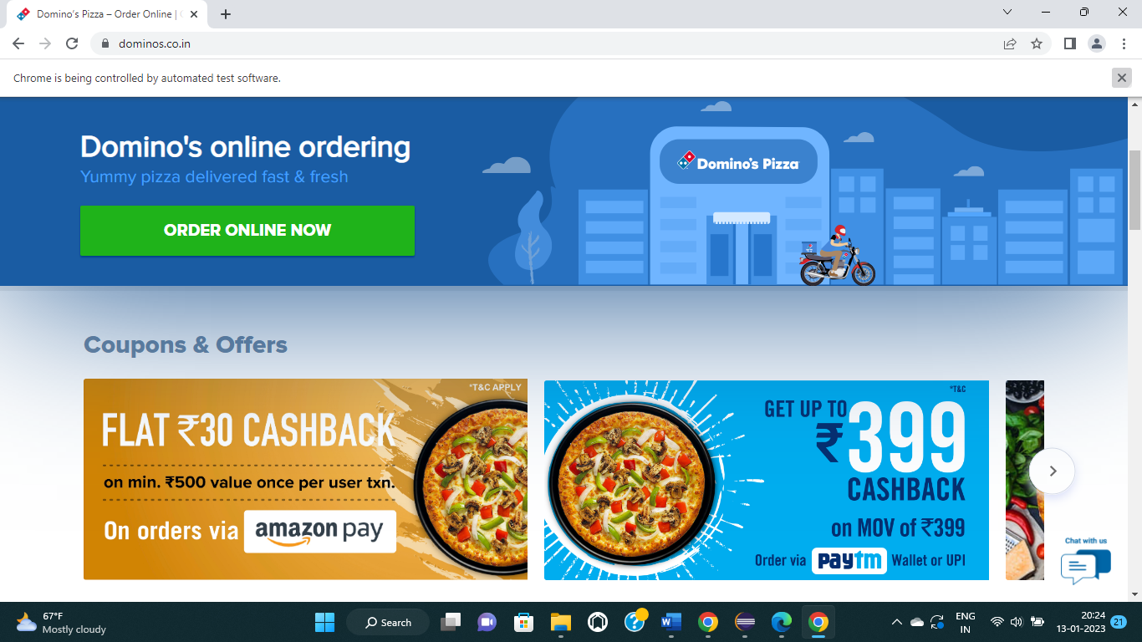

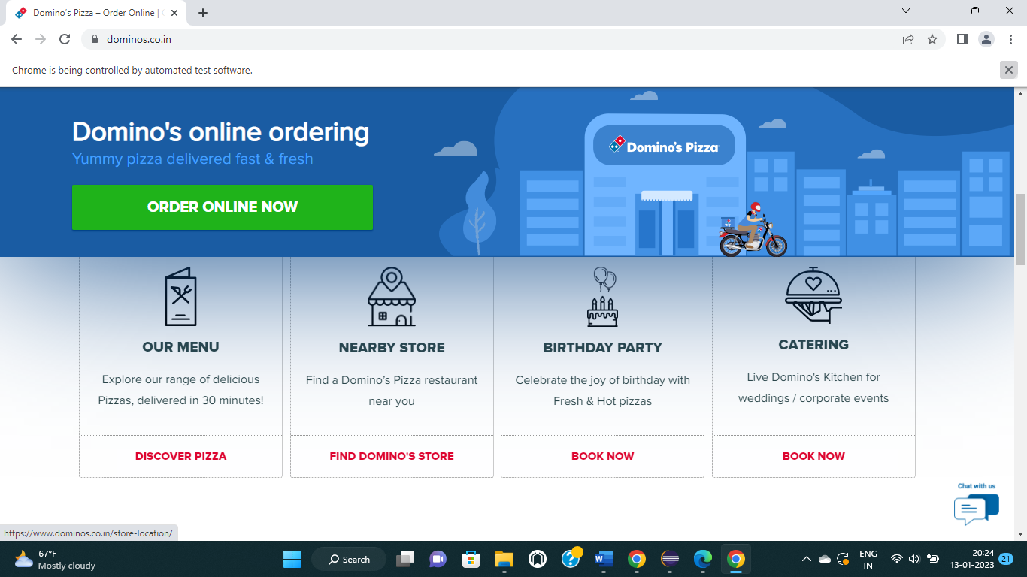

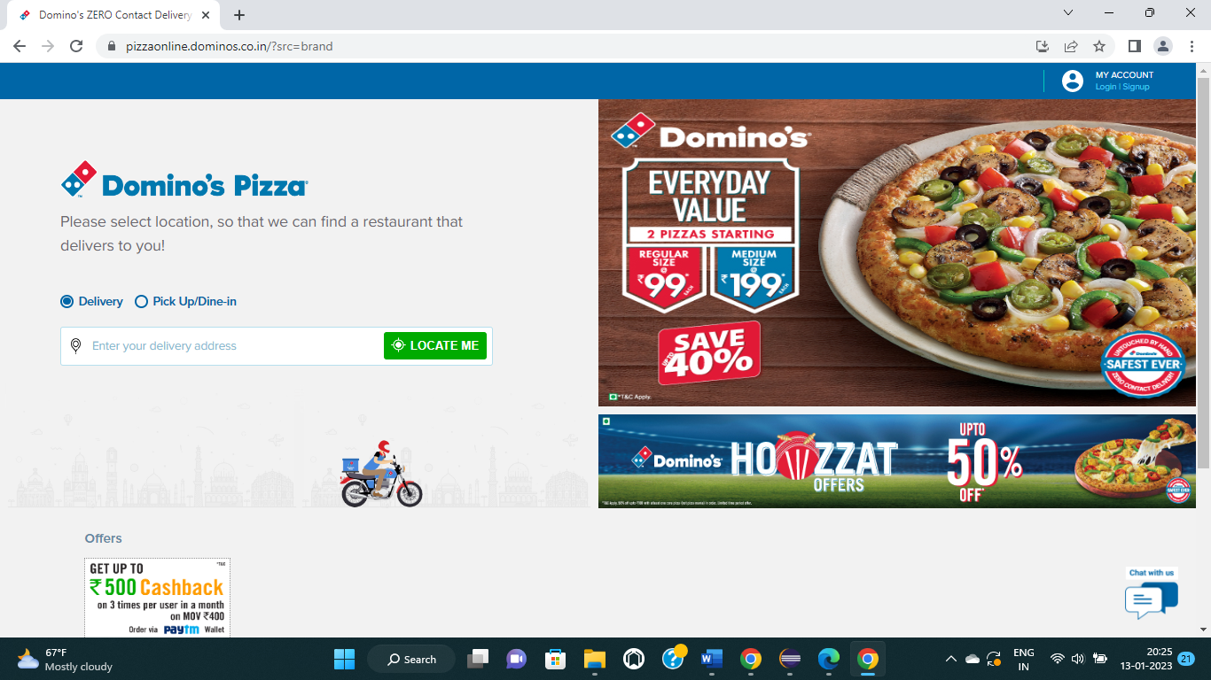

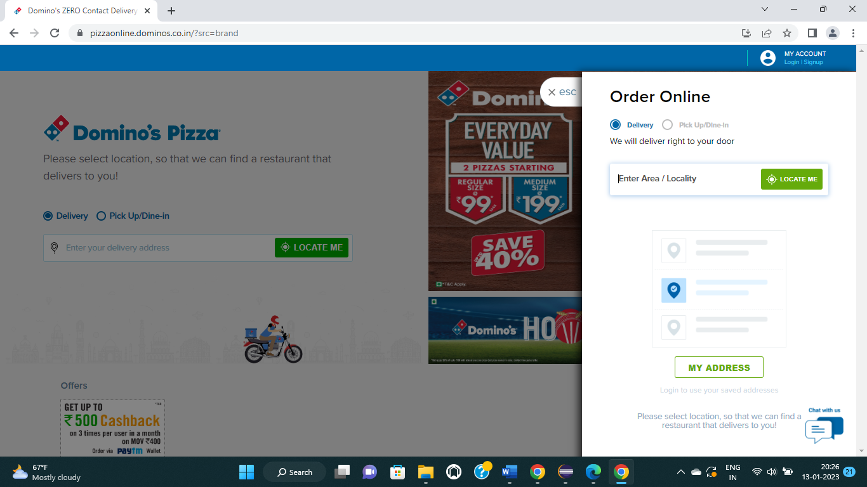

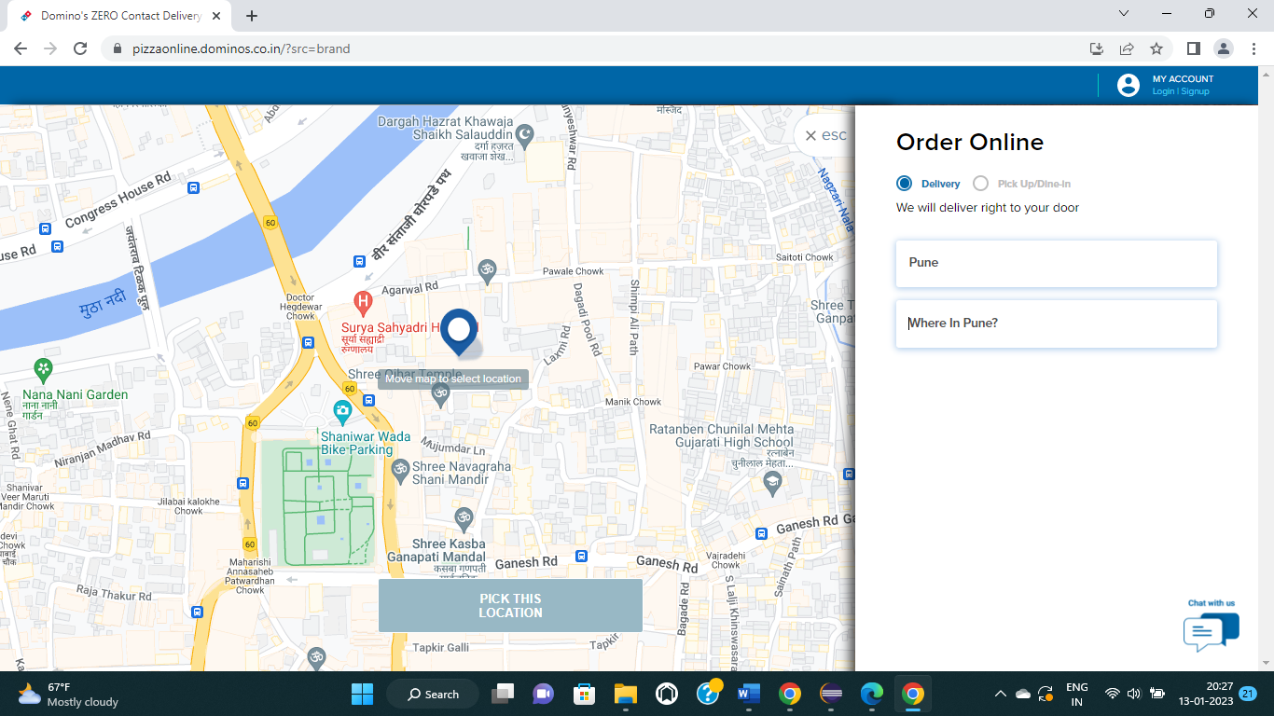

**CUCUMBER**

**Project Explorer Cucumber**

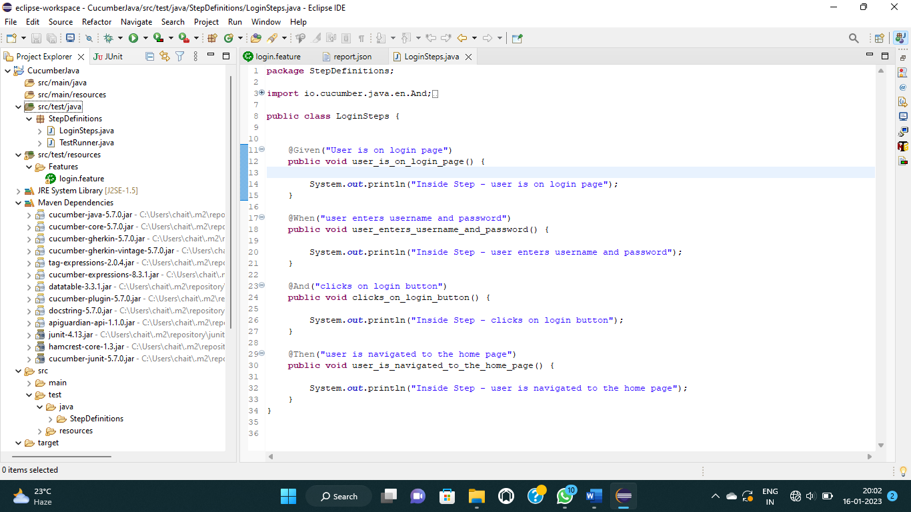

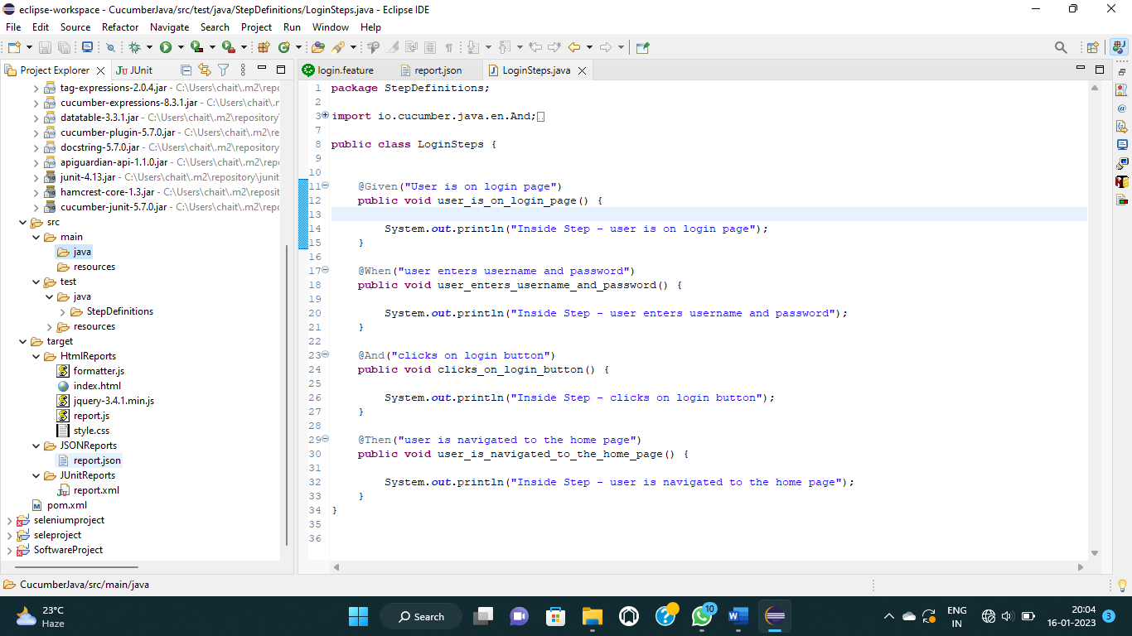

**LoginSteps.java**

package StepDefinitions;

import io.cucumber.java.en.And;

import io.cucumber.java.en.Given;

import io.cucumber.java.en.Then;

import io.cucumber.java.en.When;

public class LoginSteps {

@Given("User is on login page")

public void user_is_on_login_page() {

System.out.println("Inside Step - user is on login page");

}

@When("user enters username and password")

public void user_enters_username_and_password() {

System.out.println("Inside Step - user enters username and password");

}

@And("clicks on login button")

public void clicks_on_login_button() {

System.out.println("Inside Step - clicks on login button");

}

@Then("user is navigated to the home page")

public void user_is_navigated_to_the_home_page() {

System.out.println("Inside Step - user is navigated to the home page");

}

}

**TestRunner.java**

package StepDefinitions;

import io.cucumber.junit.CucumberOptions;

import org.junit.runner.RunWith;

import io.cucumber.junit.Cucumber;

@RunWith(Cucumber.class)

@CucumberOptions(features="src/test/resources/Features",glue={"StepDefinitions"},

monochrome = true,

plugin = {"pretty","junit:target/JUnitReports/report.xml",

"json:target/JSONReports/report.json",

"html:target/HtmlReports"},

tags="@smoketest"

)

public class TestRunner {

}

**login.feature**

#Author

#Date

#Description

@SmokeFeature

Feature: feature to test login functionality

@smoketest

Scenario: Check login is successful with valid credentials

Given user is on login page

When user enters username and password

And clicks on login button

Then user is navigated to the home page

**Index.html**

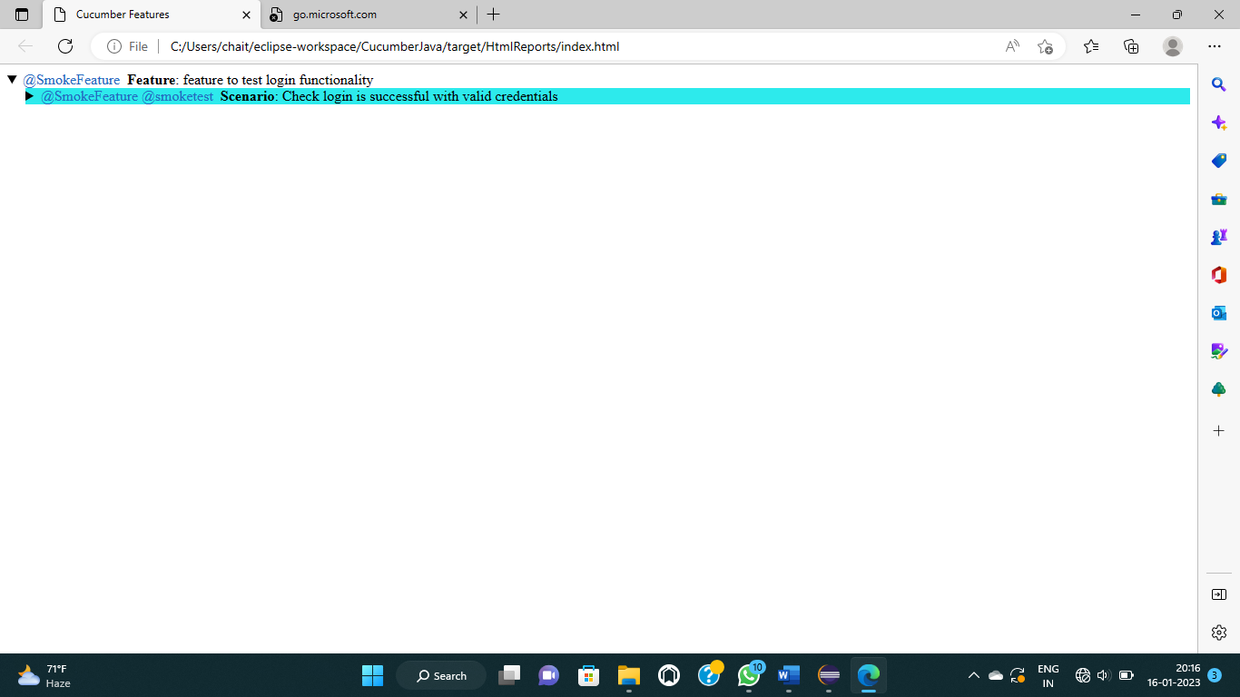

**Style.css**

.cucumber-report .body {

font-family: Helvetica,Arial,sans-serif;

}

.cucumber-report .keyword {

font-weight: bold;

}

.cucumber-report .description {

font-style: italic;

margin-left: 20px;

white-space: pre;

}

.cucumber-report details > section {

margin-left: 20px;

}

.cucumber-report ol.steps {

list-style-type: none;

margin-top: 0;

margin-bottom: 0;

}

.cucumber-report .step .embedded-text {

background: #dddddd;

}

.cucumber-report .doc_string {

margin: 0 0 0 20px;

}

.cucumber-report table {

border-collapse: collapse;

border: 1px;

border-style: solid;

}

.cucumber-report td, .cucumber-report th {

border: 1px;

border-style: solid;

padding-left: 4px;

padding-right: 4px;

}

.cucumber-report table {

margin-left: 20px;

}

.cucumber-report thead {

background-color: #C0C0C0;

}

.cucumber-report .passed {

background-color: #C5D88A;

}

.cucumber-report .undefined, .cucumber-report .pending {

background-color: #EAEC2D;

}

.cucumber-report .skipped {

background-color: #2DEAEC;

}

.cucumber-report .failed {

background-color: #D88A8A;

}

.cucumber-report .tags {

display: inline;

}

.cucumber-report .tag {

margin-right: 0.25em;

color: #246ac1;

}

.cucumber-report .comments {

display: inline;

}

.cucumber-report .comment {

margin: 0;

padding: 0;

}

.cucumber-report .error {

margin: .2em .75em;

padding: .2em;

border: 1px solid #900;

background-color: #EDBBBB;

}

#cucumber-templates {

display: none;

}

**Report.json**

[

{

"line": 6,

"elements": [

{

"start_timestamp": "2023-01-06T18:47:01.353Z",

"line": 9,

"name": "Check login is successful with valid credentials",

"description": "",

"id": "feature-to-test-login-functionality;check-login-is-successful-with-valid-credentials",

"type": "scenario",

"keyword": "Scenario",

"steps": [

{

"result": {

"status": "undefined"

},

"line": 11,

"name": "user is on login page",

"match": {},

"keyword": "Given "

},

{

"result": {

"duration": 1003200,

"status": "skipped"

},

"line": 12,

"name": "user enters username and password",

"match": {

"location": "StepDefinitions.LoginSteps.user_enters_username_and_password()"

},

"keyword": "When "

},

{

"result": {

"duration": 989300,

"status": "skipped"

},

"line": 13,

"name": "clicks on login button",

"match": {

"location": "StepDefinitions.LoginSteps.clicks_on_login_button()"

},

"keyword": "And "

},

{

"result": {

"status": "skipped"

},

"line": 14,

"name": "user is navigated to the home page",

"match": {

"location": "StepDefinitions.LoginSteps.user_is_navigated_to_the_home_page()"

},

"keyword": "Then "

}

],

"tags": [

{

"name": "@SmokeFeature"

},

{

"name": "@smoketest"

}

]

}

],

"name": "feature to test login functionality",

"description": "",

"id": "feature-to-test-login-functionality",

"keyword": "Feature",

"uri": "file:src/test/resources/Features/login.feature",

"tags": [

{

"name": "@SmokeFeature",

"type": "Tag",

"location": {

"line": 5,

"column": 1

}

}

]

}

]

**report.xml**

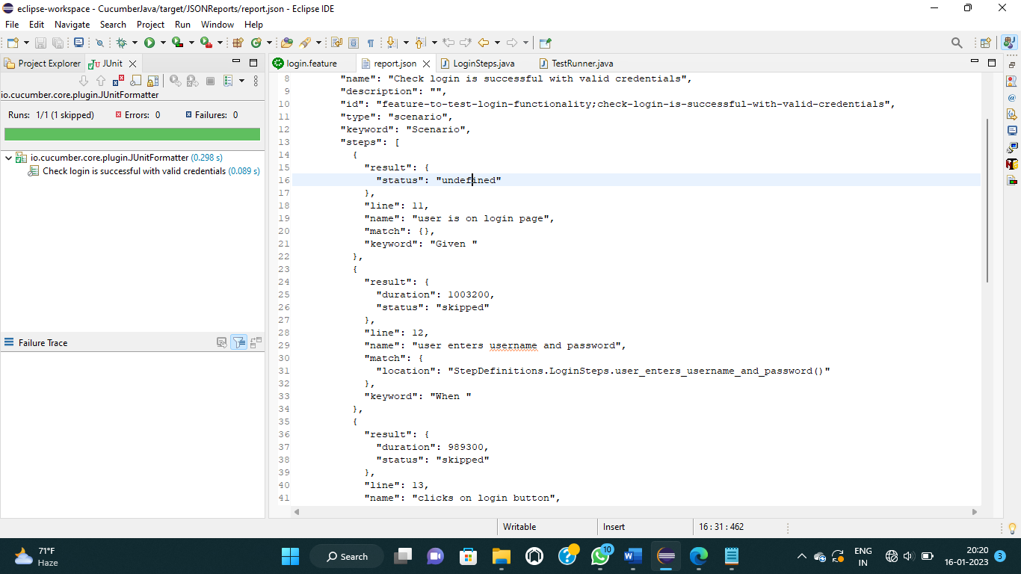

**Pom.xml**

<project xmlns="http://maven.apache.org/POM/4.0.0" xmlns:xsi="http://www.w3.org/2001/XMLSchema-instance" xsi:schemaLocation="http://maven.apache.org/POM/4.0.0 https://maven.apache.org/xsd/maven-4.0.0.xsd">

<modelVersion>4.0.0</modelVersion>

<groupId>cucumberJava</groupId>

<artifactId>cucumberJava</artifactId>

<version>0.0.1-SNAPSHOT</version>

<dependencies>

<!-- https://mvnrepository.com/artifact/io.cucumber/cucumber-java -->

<dependency>

<groupId>io.cucumber</groupId>

<artifactId>cucumber-java</artifactId>

<version>5.7.0</version>

</dependency>

<!-- https://mvnrepository.com/artifact/junit/junit -->

<dependency>

<groupId>junit</groupId>

<artifactId>junit</artifactId>

<version>4.13</version>

<scope>test</scope>

</dependency>

<!-- https://mvnrepository.com/artifact/io.cucumber/cucumber-junit -->

<dependency>

<groupId>io.cucumber</groupId>

<artifactId>cucumber-junit</artifactId>

<version>5.7.0</version>

<scope>test</scope>

</dependency>

</dependencies>

</project>